# Accessibility Guide for Shepherds View

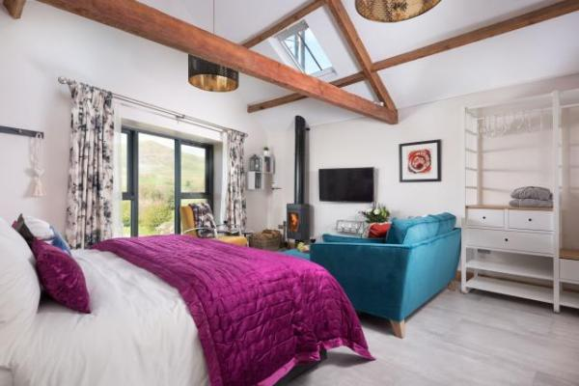

### Welcome

At Dufton Barn Holidays we want to make everyone's stay as enjoyable as possible, and are committed to providing suitable access for all our guests, whatever their individual needs. We aim to accurately describe our facilities and services to give you the confidence to book with us for your specific requirements.

Shepherds View is a luxury holiday cottage for couples set on 2 floors.  Access to the property is on ground floor level where you will also find the kitchen.  On the first floor, accessed by a stair-case, is the bedroom/lounge in a studio format and also the en-suite bathroom with bath and shower.

## At a Glance

### Level Access

* The main entrance has 1 step. There is no lift and no ramp.

### Access with steps

* There are steps from the main entrance to:
  + Bedroom
  + Lounge
  + Shepherds View Garden

### Bedrooms

* We have non-allergic bedding.

### Hearing

* The (bedroom) TVs have subtitles.

### Visual

* Full-height windows have contrast markings.
* The walls and the doors have high colour contrast.
* Some parts of the venue have low lighting.
* We have information in large print.

### General

* Staff are available 24 hours a day.
* We have emergency evacuation procedures for disabled visitors.

## Getting here

Shepherds View  
Dufton  
Appleby in Westmorland  
Cumbria  
CA16 6DB

#### Travel by public transport

* You can get to Shepherds View by bus and train.
* The nearest bus stop is at either Moot Hall or the Sands in Appleby for bus services to/from Kendal or Penrith. Unfortunately, due to its rural location, there is no regular public transport available direct to Dufton.  However, public transport services to Appleby would allow you to then take a short taxi journey to the village. The bus stop is 3.0 miles / 4.8 km from Shepherds View.
* The nearest train station is Appleby Railway Station. The train station is 3 miles / 4.8 km from Shepherds View.
* The line runs between Leeds and Carlisle and is operated by Northern.

#### Travel by taxi

* You can get a taxi with Appleby Taxis by calling 01768352772. The taxi company has a wheelchair accessible vehicle.

#### Parking

* We have a car park. There are accessible parking spaces. The parking is less than 50 metres from the main entrance. Parking is free.
* There is a drop-off point at the main entrance. The drop-off point does not have a dropped kerb.
* From the car park to the entrance, there is level access. The path is sloped.
* The route is 5000mm wide, or more.

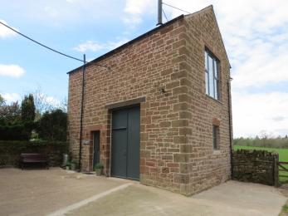  
Private car park and entrance to Shepherds View

## Arrival

#### Path to main entrance

* From the street to the main entrance, there is level access.
* The path is 5000mm wide, or more.
* The path is sloped.

#### Main entrance

* The door is 850mm wide.
* The main entrance has 1 steps.
* The main door is side hung and manual.
* When you arrive, we can help carry your luggage.
* We try to be available to meet our guests on arrival wherever possible, and can help with luggage on request.

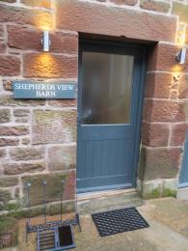  
Front Entrance

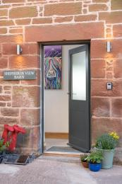  
Entrance and hall

## Getting around inside

#### Visual Impairment - General Information

* We have contrast markings on all full-height windows and high colour contrast between walls and doorframes.
* Some parts of the venue have low lighting.

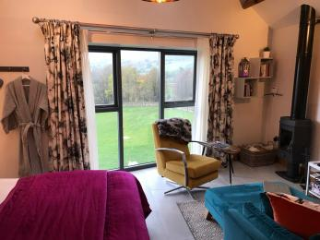  
Full length window in contrast colour

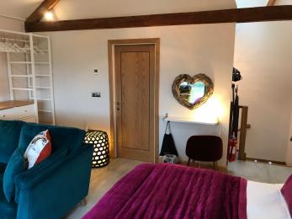  
Doors contrast to wall colour

#### Bedrooms

* All bedrooms have windows.
* Bedrooms have ceiling lights, floor standing lights, bedside lamps and natural daylight.
* Lights are LED and energy saving. TVs have subtitles.
* All bedrooms are non-smoking.
* We have non-allergic bedding.
* No bedrooms have fitted carpets.
* Non-allergenic bedding is available on request
* The bedroom nearest the main entrance has 16 steps.
* All bedrooms are ensuite.
* We have bathrooms with a separate shower.
* We have bathrooms with a bath.
* The walls and the fittings have high colour contrast.

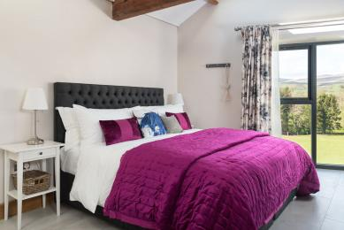  
View of the bed

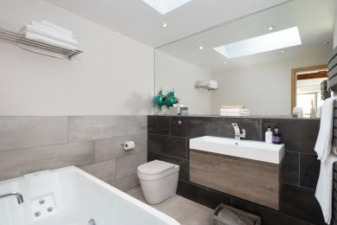  
Bath and toilet

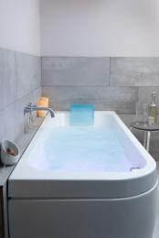  
Bath

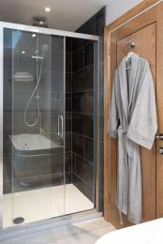  
Shower

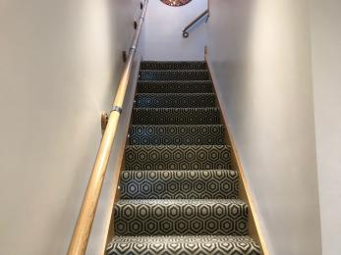  
First flight of stairs to first floor

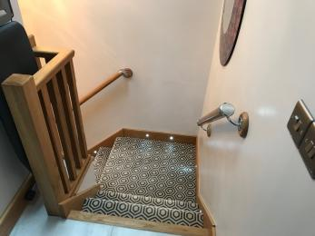  
Landing and second flight

#### Self catering kitchen

#### Kitchen

* We have an open plan kitchen.
* From the main entrance to the kitchen, there is level access.
* The route is 820mm wide, or more.
* The door is 820mm wide.
* The oven is available at a height between 650mm and 900mm.
* The table and plates have high colour contrast.

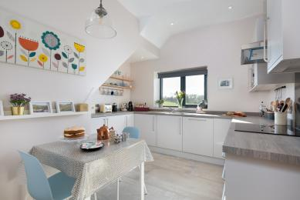  
Kitchen viewed from the door

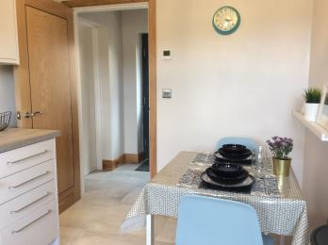  
Kitchen viewed from the window

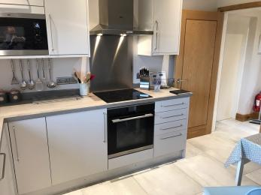  
Kitchen cook line

* From the main entrance to the dining room, there is level access.

#### Lounge

#### Lounge

* From the main entrance to the lounge, there are 16 steps. There is no lift and no ramp.

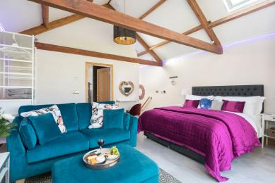  
Lounge/Bed from window

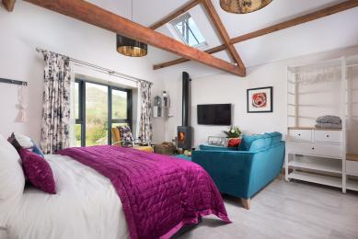  
Lounge/Bed from stairs

## Getting around outside

#### Shepherds View Garden

* From the main entrance to the area, there are 5 steps.
* There are 3 steps from the car park to the gate to the first level of the shared cottage garden.  This is followed by a short concrete path of 4440mm in length, and a further 2 steps that lead into the main garden.

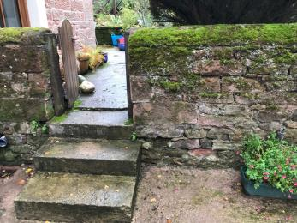  
Steps to first garden level

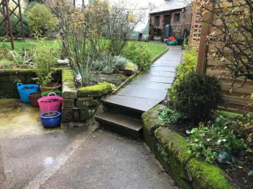  
Steps to main garden level

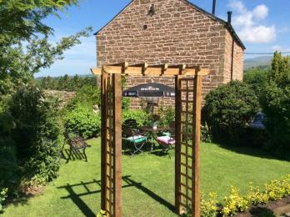  
Private garden

## Customer care support

#### Accessibility equipment

* The nearest toilet area for assistance dogs is located along the drive, 5 metres from the entrance and near the parking area.
* We have an area to charge mobility scooters and battery powered wheelchairs.
* The storage area of the barn could be used for charging but there is a low threshold to negotiate first.

#### Customer care support

* We have information in large print.
* Staff are available 24 hours a day.
* We live in the property next to the holiday cottage.

Guide last updated: 14 October 2019