# Accessibility Guide for The Pennine Potting Shed

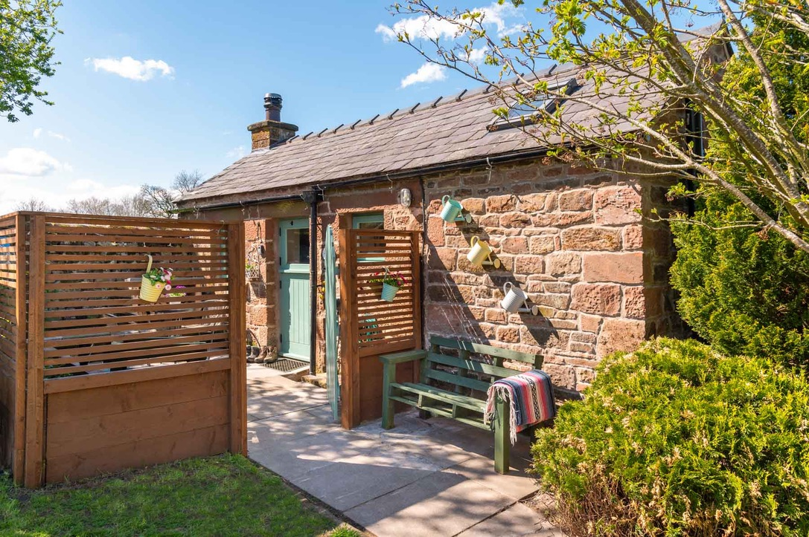

### Welcome

At Dufton Barn Holidays we want to make everyone's stay as enjoyable as possible, and are committed to providing suitable access for all our guests, whatever their individual needs.  We aim to accurately describe our facilities and services to give you the confidence to book with us for your specific requirements.

The Pennine Potting Shed is a walkers bothy for up to 3 people.  Access to the property is on ground level, but in order to access the cottage you need to climb 2 short flights of external garden steps.  All facilities are on ground level with the exception of the top bunk of the bunk bed.

## At a Glance

### Level Access

* The main entrance has 1 step. There is no lift and no ramp.
* There is level access from the main entrance to:
  + Bathroom
  + Private Garden

### Bedrooms

* We have non-allergic bedding.

### Level access bedrooms

* From the main entrance to the bedroom, there is level access.
* The route to the bedroom is 750mm wide, or more.

### Visual

* Glass doors have contrast markings.
* The walls and the doors have high colour contrast.
* Some parts of the venue have low lighting.

### General

* Staff are available 24 hours a day.
* We have emergency evacuation procedures for disabled visitors.

## Getting here

The Pennine Potting Shed  
Dufton  
Appleby in Westmorland  
CA16 6DB

#### Travel by public transport

* You can get to The Pennine Potting Shed by bus and train.
* The nearest bus stop is at either Moot Hall or the Sands, both in Appleby for bus services to/from Kendal or Penrith. Unfortunately, due to its rural location, there is no regular public transport available direct to Dufton.  However, public transport services to Appleby would allow you to then take a short taxi journey to the village. The bus stop is 3.0 miles / 4.8 km from The Pennine Potting Shed.
* The nearest train station is Appleby in Westmorland. The train station is 3 miles / 4.8 km from The Pennine Potting Shed.
* The line runs between Leeds and Carlisle and is operated by Northern.

#### Travel by taxi

* You can get a taxi with Appleby Taxis by calling 01768352772. The taxi company has a wheelchair accessible vehicle.

#### Parking

* There is a drop-off point at the main entrance. The drop-off point does not have a dropped kerb.
* There is no parking available on the site for this property.  However, street parking is available in the village and also in the village car park.

## Arrival

#### Path to main entrance

* From the street to the main entrance, there are 6 steps. There is no ramp and no lift.
* The path is sloped.

#### Main entrance

* The door is 760mm wide.
* The main entrance has 1 steps.
* When you arrive, we can help carry your luggage.

## Getting around inside

#### Visual Impairment - General Information

* We have contrast markings on all glass doors and high colour contrast between walls and doorframes.
* Some parts of the venue have low lighting.

#### Bedrooms

* All bedrooms have windows.
* Bedrooms have ceiling lights, bedside lamps and natural daylight.
* Lights are LED and energy saving. All bedrooms are non-smoking.
* We have non-allergic bedding.
* No bedrooms have fitted carpets.
* We have wi-fi free bedrooms, for visitors with electro-sensitivity.
* From the main entrance to this area, there is level access.

#### Self catering kitchen

* We have an open plan kitchen.
* From the main entrance to the kitchen, there is level access.
* The route is 760mm wide, or more.
* The table and plates have high colour contrast.

#### Lounge

* From the main entrance to the lounge, there is level access.
* The property is open plan with lounge and bedroom as one space.

#### Bathroom

* From the main entrance to this area, there is level access. The route is 760mm wide, or more.
* The door is 760mm wide.
* The bathroom is accessed via the kitchen and has a sliding door to save space.

## Getting around outside

#### Private Garden

* From the main entrance to this area, there is level access.
* The property has a private garden with some standard outside furniture to relax in.

## Customer care support

#### Accessibility equipment

* The nearest toilet area for assistance dogs is in the garden, just outside the property.

#### Customer care support

* Staff are available 24 hours a day.
* We live next door to the property

Guide last updated: 14 October 2019