

**Welcome**

We are delighted to welcome you to Shepherds View Barn and hope that you have a wonderful stay with us. If this is your first visit to the Eden Valley we hope that you enjoy the wide range of activities that the area has to offer, and we will be delighted to point you in the right direction of things that you personally have interest in should you need any inspiration.

Please feel free to knock on the door at any time if you have any questions or problems or you can also contact us on our home number or by email during your stay. Our mobiles are also below in the event that you can’t get hold of us, but due to the signal strength this can be intermittent, so please do not text if you need a quick response.

*Carole & Simon*

Home: 017683 52167

Email: stay@duftonbarnholidays.co.uk

Mobiles: 07990582422 – Carole 07359642243 - Simon

**Day of Departure**

Please vacate the property no later than 10am on the day of your departure to allow us time to prepare the barn for the arrival of our next guests at 4pm. We would ask that you please leave the barn as tidy as possible and return crockery etc to the kitchen. Please put all used dressing gowns, towels, and bath-mat in the washing basket which you will find in the utility area.

If for some reason we are not around for your departure please leave the key in the key box located outside the barn front door – code 2002.

**KEY FACILITIES**

**The Kitchen**

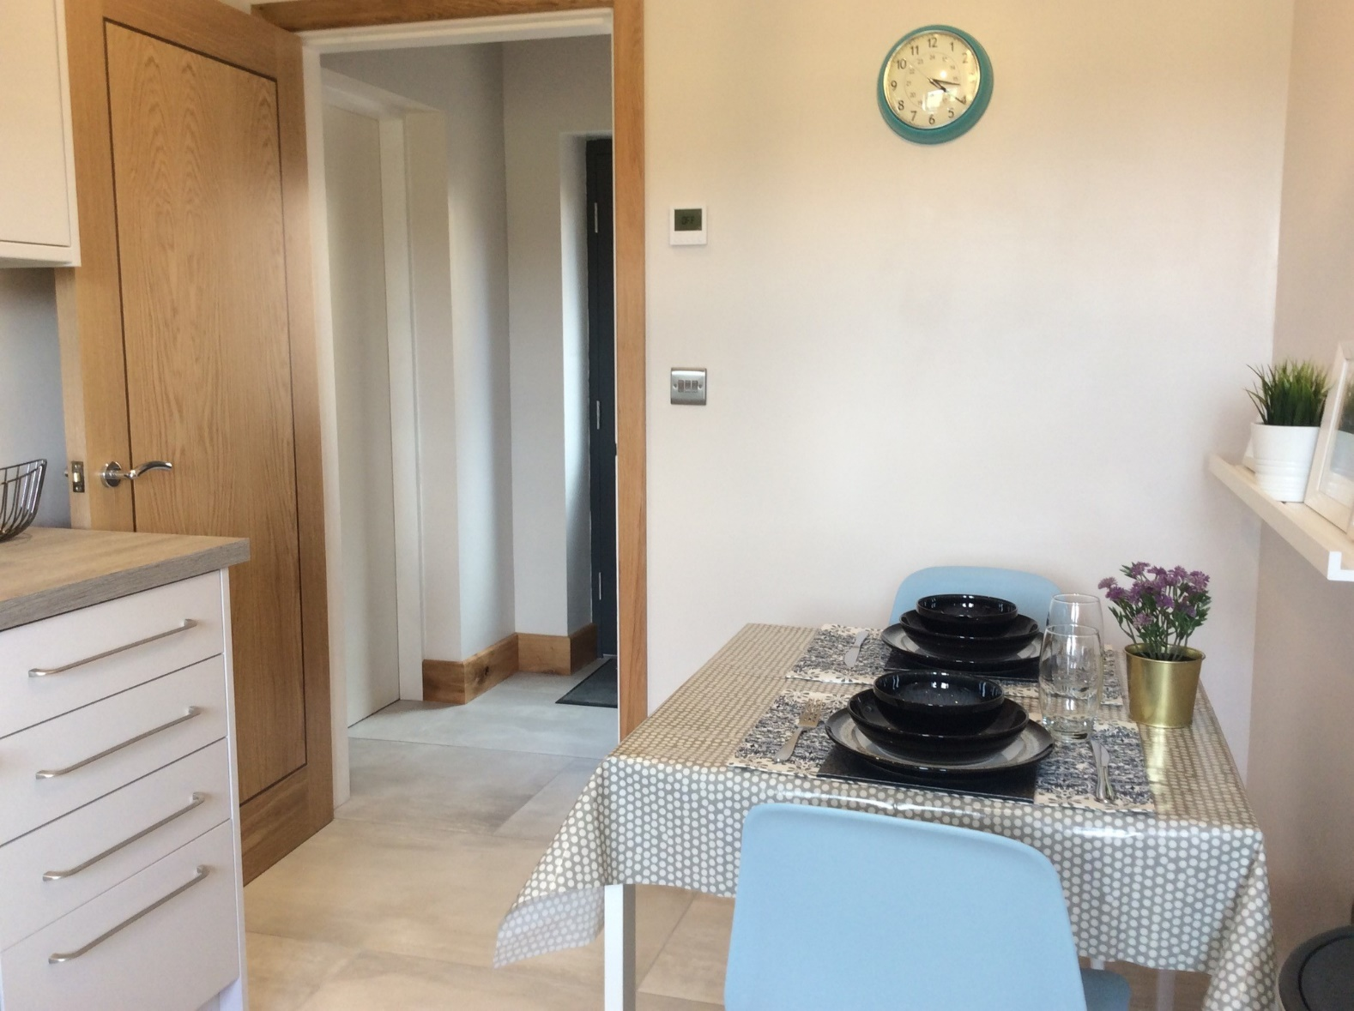

Hopefully you will find everything you need to self-cater during your stay at Shepherds View. If not, then please let us know as soon as possible so that we can provide you with what you need. Instructions on the use of the oven/microwave/dishwasher/washer-dryer are available on cards near the relevant piece of equipment. Similarly, there is a Lavazza coffee machine for your enjoyment with a selection of pods available. If you need any further coffee pods, then please just let us know.

At the end of your stay can we please ask that you return all crockery and utensils to their original place, as this would be greatly appreciated.

**The Lounge / Bedroom**

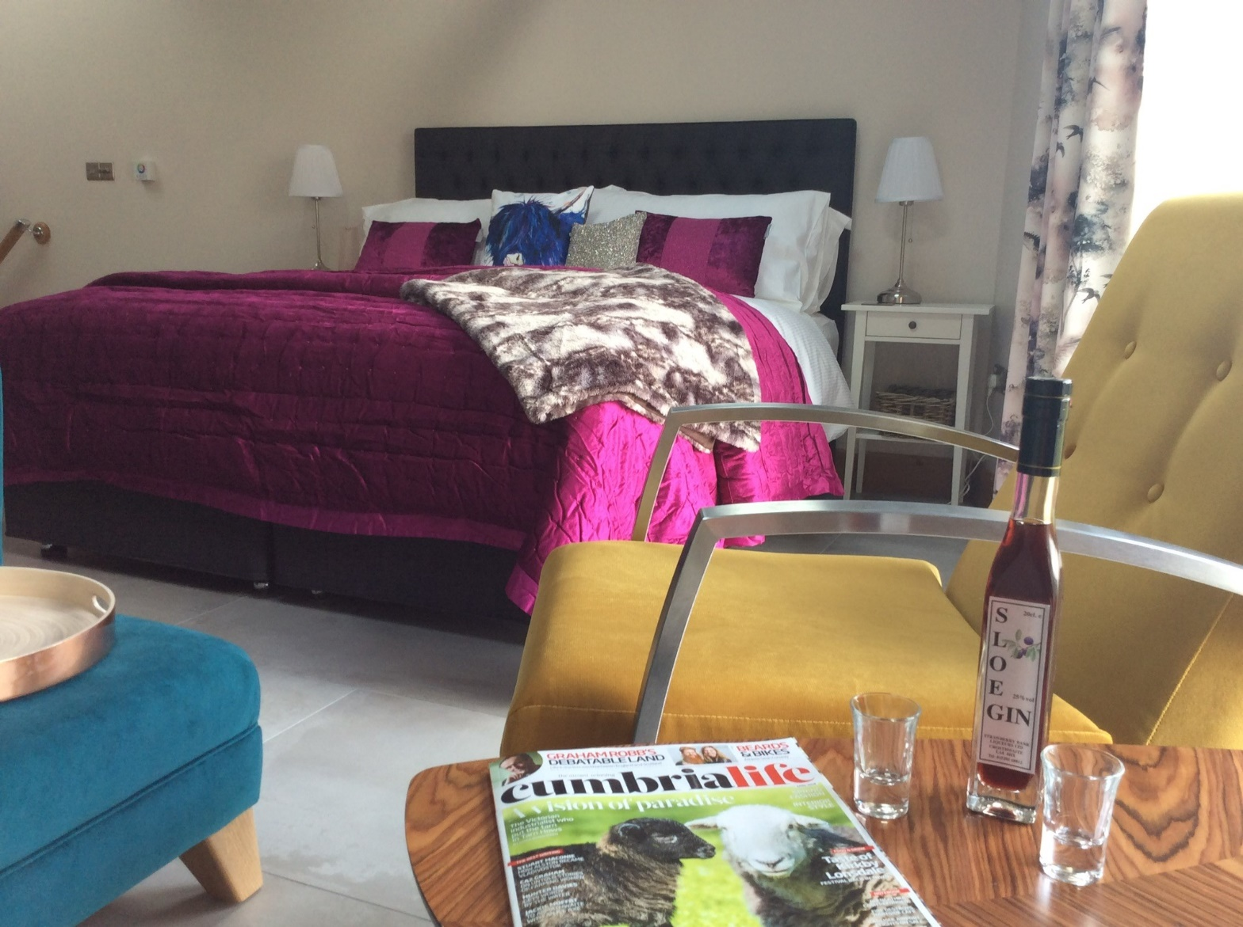

The Velux windows are automatic and can be opened or closed using the remote control located on the wall by the bed. Similarly, the window blinds are also operated this way. Windows/blinds can be opened individually or together for your convenience. Please close them if you go out particularly in the Spring when the Swallows and House-martins are about and looking to nest! They also have a rain sensor on them to prevent them being opened in the rain, and we would ask that you don’t open them in strong winds, particularly if there is a Helm Wind blowing! For further information on the only named wind in England visit [www.duftonvillagehall.com/the-helm-wind](http://www.duftonvillagehall.com/the-helm-wind).

If you don’t need all the cushions on the bed then you will find 2 drawers down each side of the bed base where you can store them.

We understand that everyone has different requirements when it comes to Duvet thickness. Please let us know if you are too hot or too cold and we can supply you with an appropriate Tog duvet.

There are a selection of games and jigsaws under the TV storage unit.

**The Bathroom and Jacuzzi bath**

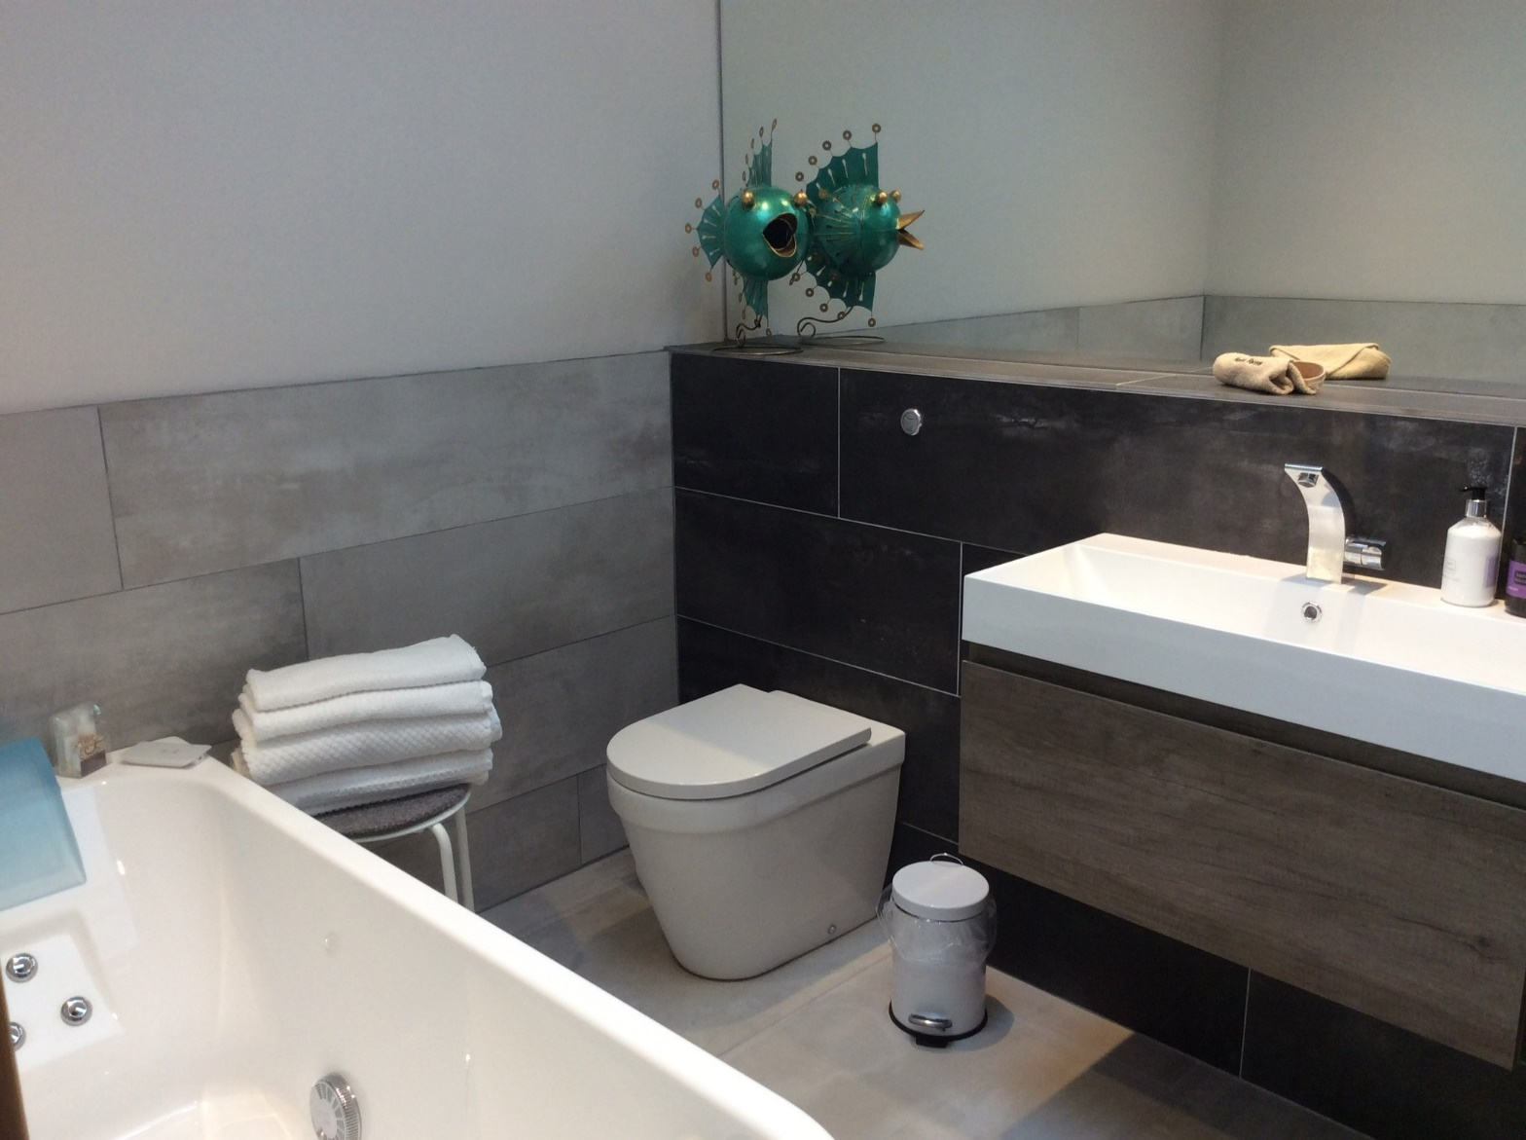

Instructions on how to use the Jacuzzi bath can be found on a card in the bathroom. Please read these instructions carefully before use so that you get the maximum enjoyment from the experience, but also to ensure that the water stays in the bath as the jets are powerful!

We clean the Jacuzzi between every guest visit, and it also has a specialised air jet system that closes so as not to allow water to rest in the jets when not in use. There is a water heater and lighting on the bath for that fully immersive experience and the standard programme runs for around 20 minutes. The handset charger can be found under the sink.

We would ask that you ensure that the bathroom extraction is always on when you have a shower or a jacuzzi bath as the Jacuzzi generates a lot of steam. The extractor comes on with the bathroom light and runs for about 20 minutes when the light is switched off – this is to enable you to enjoy the jacuzzi lighting system with the main lights off. The extractor switch is located on the wall to the left of the bathroom door.

**PLEASE DO NOT PUT BUBBLE BATH/BATH BOMBS IN THE BATH – it will completely fill the bathroom with bubbles and can damage the bath!!!!!!!**

**Heating**

The main method of heating is underfloor heating which is throughout the property. This is controlled by 2 thermostats working independently to each other and located on the wall in the kitchen and in the bedroom/lounge. The heating is programmed to be on from 5.30am until 10.30pm and designed so that the floor temperature does not fall too much during the day. After 10.30pm the heating is on at 10C to maintain heat in the floor.

**Too hot** - simply turn the heating off by pressing the ON/OFF button which is the left-hand button on the control.

**Too cold** - put the system into manual mode by pressing the M (manual) button once so that the symbol of a hand is displayed. You can then adjust the temperature using the up/down arrows. As the system is underfloor it will take slightly longer to warm up than standard central heating – please note setting a very high temperature will not make it reach temperature quicker.

We would ask that you put the heating back into auto mode (by pressing the M button so that AUTO is displayed) if you go out. If you are cold or are unsure how to work the system then please do ask, as we want you to be comfortable during your stay.

**Log burner**

As an additional form of heating feel free to use the log burner, which will top up the heating in cold spells, but also looks and feels good! Remember that with the log burner on that the thermostat will reach temperature quickly so this will knock off the heating so please do not adjust the thermostat if the log burner is working. Instructions on using the log burner can be found on a card next to it and we have left you with a full basket of logs. There are plenty more logs which you will find in our store area through the door by the kitchen/entrance. Please help yourself as you need.

**Parking**

Parking for the cottage is directly outside the door to Shepherds View. We would ask that you do not park in front of the field gate as this is a farm access road, and whilst the access is not used very frequently there may be the odd occasion where it is.

**Garden and Dogs**

Feel free to enjoy the garden which is accessed via the steps and through the small wooden gate. For your privacy the area immediately to the right as you enter the garden is for your exclusive use and you will find additional furniture in the Summerhouse. Dogs are welcome in this space but please do not allow your dog to use the area for its toilet as this damages the grass. You may take your dog down the drive or better still on to the village green.

**Store Area / Boot Cleaning / Logs**

The door to the right as you enter the property is a store area and where the boiler and control unit is located. Please do not adjust any of the boiler control units. The water stop-cock is located to the bottom left hand side of the boiler and you will need to look at ground level to see it.

You can lock this door from your side, so you can access this area as you need, but also lock it off. Please feel free to store your bikes in here or any other muddy/bulky equipment, and there is a key for the barn door hanging up on the wall just inside. There is a sink here where we would ask that you clean your boots or other muddy equipment, and a store for additional logs. You can also find a laundry airer stored above the sink, but you are welcome to use the rotary washing line in the garden – pegs are under the sink in the kitchen. Please be aware that we still use this space to store some of our equipment so don’t be surprised to see us come in here, but we will try to minimise this as much as possible to preserve your privacy.

**Re-cycling / Rubbish Bin collection**

There are recycling facilities in the village which can be found at the village car park. You can recycle paper, cardboard, glass, tins, cans, and foil here. If you can separate out your plastics and cardboard/paper into the plastic boxes in the store, we will recycle this for you as there is a fortnightly collection. Rubbish is collected every Wednesday and we will organise this for you from the bin that is directly outside your property.

**Any Problems / Breakages / Damage**

We have tried to ensure that you have everything you need to enjoy your holiday at Shepherds View to the full, and we do check that everything is working properly before your arrival. However, if something is not to your satisfaction please let us know as soon as possible and we will endeavour to sort out the issue. We don’t want anything to fester for too long especially as we want you to enjoy your well-earned break.

Also, if there is something you need that we haven’t thought of then please let us know or alternatively knock on the door at any time or if we are out please phone and leave a message on 01768352167.

We also understand that accidents do happen. We would be grateful if you could leave us a note or let us know if anything has been broken or damaged so that we can arrange repair or replacement. For minor damage there will be no charge, but for more serious damage we may unfortunately need to levy a repair charge.

**Smoking / Fire Action**

The property is a no-smoking property throughout, and we ask that you respect this by not smoking or vaping anywhere in the property, including the bathroom, or out of windows or doors. Please feel free to smoke outdoors - there is an umbrella by the front door for you to use if the weather is inclement. Smoke-alarms are situated both up and down stairs for your safety, are tested weekly and should not be covered over under any circumstance.

For your safety please ensure that the kitchen door is kept shut as the walls and door have a 30-minute fire protection rating to protect your main escape route down the stairs. We recommend you keep the front door key in the door when you are in the property so that you are able to exit quickly. There is a fire blanket in the kitchen for fat fires. It is now illegal to light candles in a self-catering property, which is why we do not provide them.

In the event of a fire please leave the property via the stairs and main entrance if safe to do so. Alternatively, if the stairwell is blocked then the main windows on the first floor will open to allow exit, but due to the drop we would recommend you wait for the fire brigade which are stationed in Appleby 3 miles away.

**Internet & mobile**

The Wifi access code can be found in a frame by the TV. You will find the router in the main room upstairs to the left of the TV and there should be 3 green lights showing that it is working properly. If you have any issues with the internet service please let us know and we will investigate.

Parts of the village can be poor for mobile signals due to the hills & valleys, and the upper level of the barn is better than the ground floor.

**Television and Music System**

Instructions on the use of both the TV and the Bose music system are on a card located near the TV. You can connect your phone or tablet to the Bose system via Bluetooth so that you can play your music.

Netflix is provided which you can access by pressing the Netflix button on the TV remote and we have set up a Shepherds View Guest profile for your personal use.

If you use Amazon Prime or any of the other on-line Apps on the TV using your own private log-in codes please remember to sign out before leaving the property.

**EV Charging**

The unit is an ICS charger and is suitable for all EV cars, but you will need to have your own Type 2 cable connection appropriate for your vehicle.

Download the Charge Assist app and follow the instructions when you log in to link with our EV charger, which gives you access to the payment options. Alternatively you can use your phone to scan the QR code located on the front of the charger.

Charging an EV from one of our standard domestic 13A sockets is not permitted, could be dangerous, and may invalidate our insurance.

The nearest alternative charging point is at Appleby Manor and is a BP Pulse unit, and other units are available in Penrith at Morrisons and Booths.

**Bookshelf**

We have carefully selected a number of books for their local interest. Could we please ask that you return any books to the bookcase prior to your departure, for the enjoyment of future guests.

**Fireworks**

Due to the rural location of the property and the proximity of livestock, fireworks are not permitted at any time. Thank you for your understanding on this.

**Local Information – you will need a parking disc (provided in the cottage) for street parking in any disc zone marked spaces in the Eden Valley and across Cumbria/Lake District**

**Supermarkets**

Appleby for essentials - Co-op / Spar / 2 good butchers / fruit and veg / bakery

Penrith for bigger shops - Morrisons / Sainsburys / Booths / Cranston’s / Aldi / M&S Food

**Tourist information** Appleby centre / Penrith centre

DIY in Appleby Pigney’s: great old-fashioned shop where you can buy nearly everything  
 JT Atkinsons – builder’s merchants

Banks Cumberland Building Society in Appleby/Penrith for other banks

Post office Appleby – there is also a post box in Dufton with a 9am collection

Cash points Post Office / Spar / Co-op

Newsagent Appleby – Dents – delivering to the bus stop in Dufton

Churches Dufton – Church of England / Methodist

Appleby – Church of England / Methodist

Opticians Mike Addison’s in Appleby

Chemist Appleby – Boots

Bakery Appleby – The Appleby Bakery

Petrol BP on the A66 just before entering Kirkby Thore  
 Pigney’s in Appleby during shop hours  
 Penrith – several including Morrisons

**Local Walks, Cycle Routes and Road Trips – see the laminated maps provided**

For information on the village of Dufton in terms of history, geology or the famous helm wind then please visit[**https://www.duftonvillagehall.com/dufton-village**](https://www.duftonvillagehall.com/dufton-village)

**Useful Numbers/Doctors etc**

Doctor’s surgery 017683 51584

Chapel Street, Appleby CA16 6QR

Dentist 017683 51024  
The Limes, The Sands, Appleby CA16 6XN

Optician 017683 53199 (closed Mondays)  
Mike Addison, The Sands, Appleby CA16 6XN

First Responders Despatched by 999 service

Hospital Penrith – Minor A&E – Bridge Lane CA11 8HX  
 Carlisle – Cumberland Hospital, Newtown Road CA2 7HY

Appleby Taxi 017683 52772 – c.£10 to £15 to Appleby one-way

The Stag Pub, Dufton 017683 51608

**Entertainment / Leisure**

Carlisle Vue Cinema

Keswick Theatre by the Lake

Penrith Alhambra Cinema

Rheged Cinema/Theatre

Appleby Leisure Centre 017683 51212 (swimming pool/gym)

There is a Defibrillator unit opposite the bus stop outside the toilets at the car park in the centre of the village.